**Title: Airline Passenger Satisfaction Report:** A Comprehensive Analysis by Aderinkola Abdulazeez

**Introduction**

In today's dynamic airline industry, where competition is intense and customer expectations are constantly evolving, ensuring passenger satisfaction is crucial for airlines to thrive. As air travel becomes more accessible and integral to global connectivity, understanding the factors influencing passenger satisfaction is essential for strategic planning.

This project aims to explore various aspects of airline passenger satisfaction by employing comprehensive analysis techniques to identify, assess, and prioritize the key factors shaping passengers' perceptions and experiences. By examining different stages of air travel, from pre-flight procedures to in-flight services and post-flight interactions, this research seeks to provide actionable insights to enhance overall passenger satisfaction.

**Aim**

The aim or goal of this project is to guide an airlines company to determine the important factors that influence customer or passenger satisfaction.

**Objectives**

1. Analyzing the Airline Passenger dataset using various tools in Power Bi and presenting it through Microsoft word.
2. Analyzing various factors to improve customer satisfaction using age, gender, type of travel, travel class, and entertainment options.
3. Analyze correlations between different satisfaction factors and overall satisfaction.

**About the Dataset**

The dataset utilized in this project was sourced from Kaggle and originates from a survey conducted by airlines to gauge passenger/customer satisfaction across various factors. Comprising 25 columns, the dataset encompasses crucial parameters including Age, Gender, Travel class, Arrival and Departure delays, as well as pivotal elements influencing customer satisfaction such as On-board service, Cleanliness, Seat comfort, and Baggage handling, among others.

Of particular significance is the presence of a column or feature labeled ‘satisfaction’, which delineates the overall satisfaction level of the customer. This feature serves as the cornerstone of the dataset, encapsulating the customer's holistic experience. Notably, the ‘satisfaction’ feature comprises two distinct values: neutral or dissatisfied’ and ‘satisfied’. Functioning as the label feature, it encapsulates the culmination of ratings across other features, thus providing a succinct portrayal of the customer's satisfaction level.

**Data Cleaning and Visualization**

Data preprocessing is a critical step in optimizing the performance of a machine learning model. Typically, this involves tasks such as identifying and handling outliers, addressing missing values, dealing with duplicates, and managing irrelevant or redundant features.

In the context of this project, the 'Arrival Delay in Minutes' column contained 393 missing values. To rectify this, we input the missing values with the means of the non-missing values within the same column. Python, within a Jupyter notebook environment, was utilized to execute the data cleaning process. A snippet of the code used to calculate the mean value and replace the missing values is provided below.

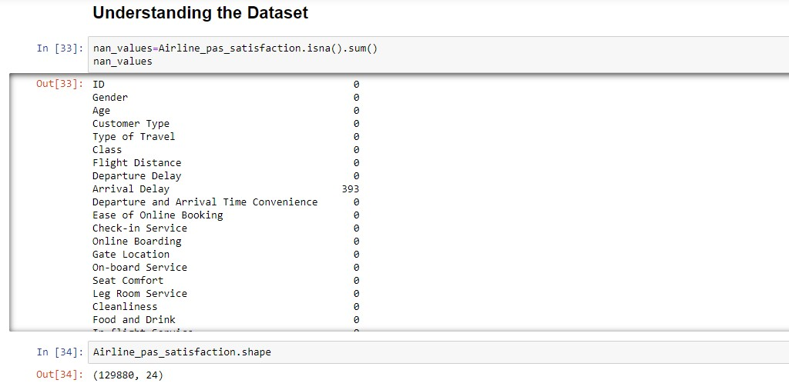

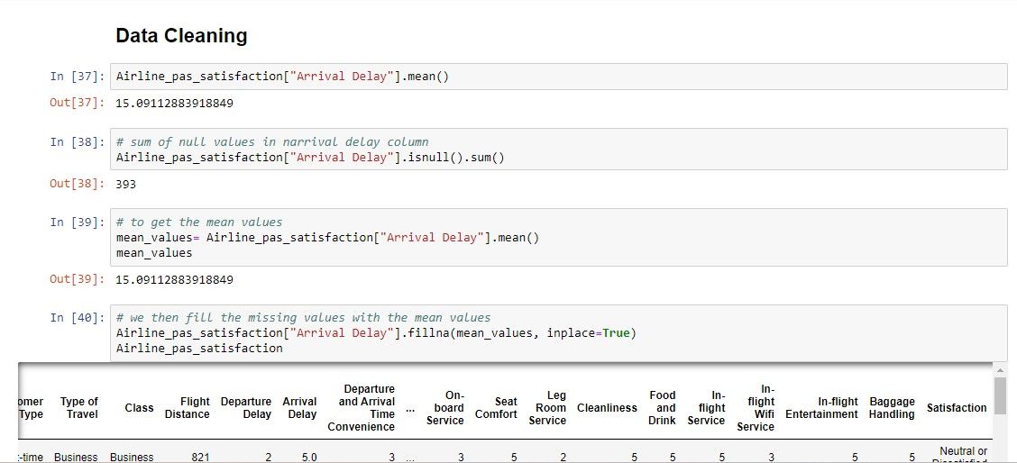

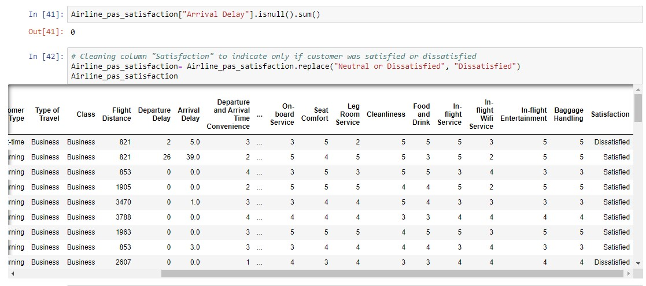

To facilitate correlation analysis between various satisfaction factors and the overall satisfaction level, we encoded the 'satisfaction' column. We assigned the value 5 for 'satisfied' and the value 1 for 'dissatisfied'. This encoding scheme allows for a more straightforward interpretation of the relationship between individual satisfaction factors and the overall satisfaction rating.

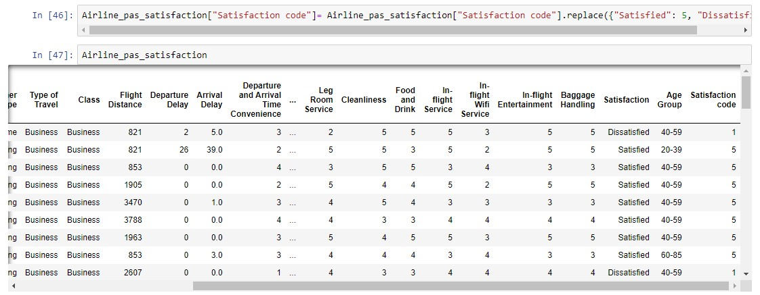

We grouped the age column based on different age groups to categorize the age classes based on children, teens, adults, and elderly.

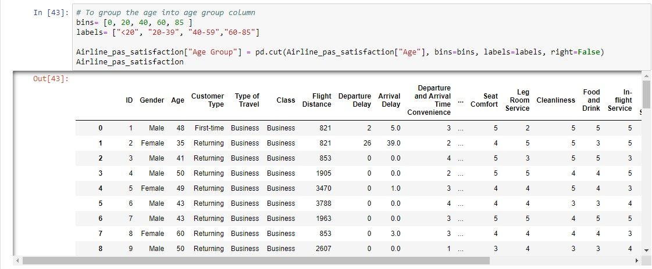

Data visualization is a pivotal tool in comprehending datasets, providing an insightful overview before model implementation. Exploratory Data Analysis (EDA) is conducted to gain deeper insights into the dataset.

Furthermore, we analyzed the correlation between various satisfaction factors and the overall satisfaction rating.

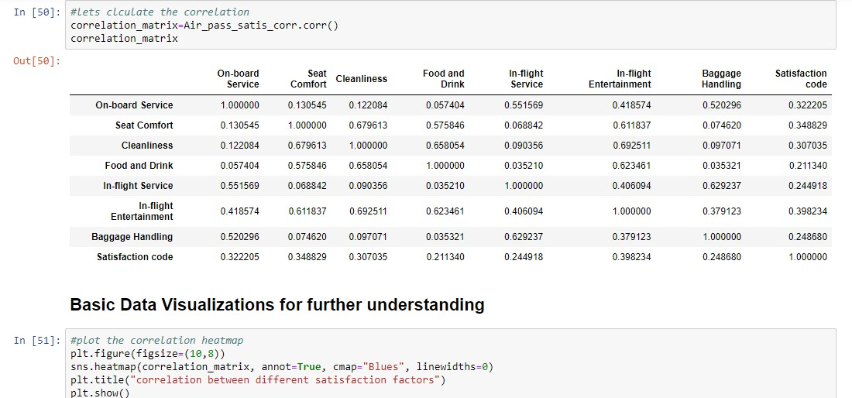

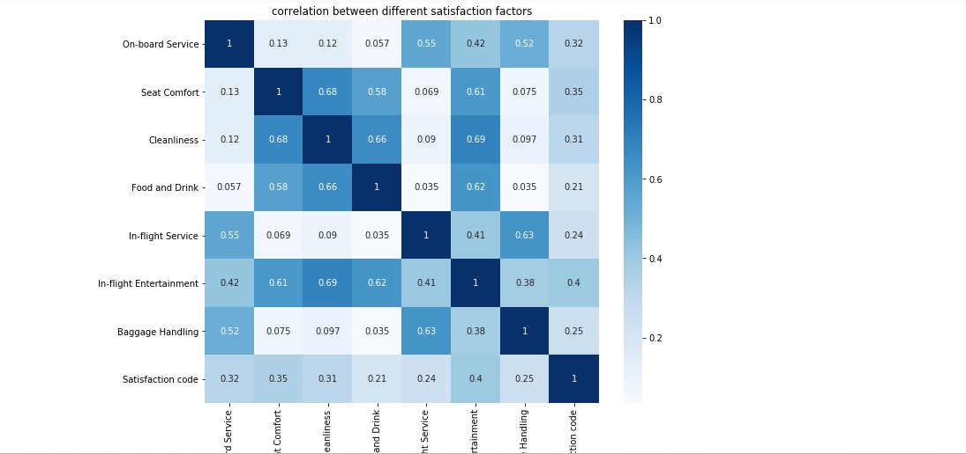

Each square in the correlation matrix displays the correlation coefficient between the variables on its respective axes. Values nearer to zero signify a weaker linear relationship between the two variables. A correlation coefficient close to 1 indicates a stronger positive correlation, implying that as one variable increases, so does the other, with a stronger relationship as the coefficient approaches 1. The diagonal squares are uniformly dark blue, indicating perfect correlation, as each variable is being correlated with itself. Notably, the correlation between cleanliness and seat comfort is highest, while the correlation between cleanliness and onboard service is lowest.

**FINAL DASHBOARD USING POWER BI**

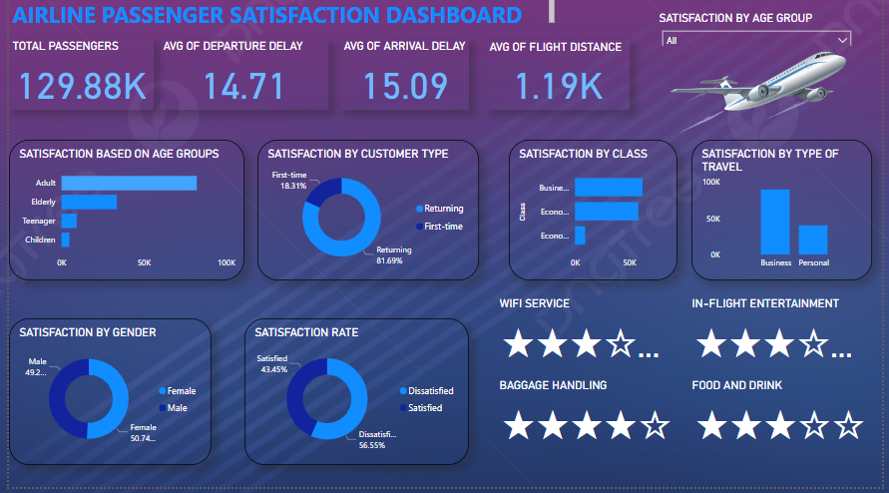  
**Airline Passenger Satisfaction Dashboard**

**Key Insights**

1. Passengers aged between 7 to 39 years, encompassing children and teenagers, require heightened attention as they exhibit the highest rate of dissatisfaction. Thus, prioritizing their needs and ensuring a satisfactory experience is imperative.
2. Improvements in satisfaction levels below 4 stars should be prioritized, focusing on key areas such as WiFi services, inflight entertainment, food and drinks quality, ease of online booking, cleanliness, and gate location convenience. These aspects warrant immediate attention to enhance overall passenger experience and satisfaction.
3. There is a pressing need to address the high rate of dissatisfaction in the Economy Plus class, while simultaneously acknowledging the relatively high satisfaction rates in both the Business and Economy classes. Urgent attention is required to rectify issues specifically affecting the Economy Plus passengers to improve their overall experience and satisfaction.
4. There is a significant disparity in satisfaction levels between returning passengers and first-time passengers, indicating a notable gap margin. This contrast underscores the importance of conducting a thorough examination to understand the underlying reasons behind this discrepancy and to address any potential issues affecting the satisfaction of both returning and first-time passengers.

**Recommendation**

Given the observed trend of higher dissatisfaction rates among passengers aged between 7 to 39 years, particularly children and teenagers, it is crucial to prioritize their needs to enhance overall satisfaction levels. To address this, airlines should consider implementing the following recommendations:

1. Tailored Services: Develop and implement age-appropriate services and amenities specifically designed to cater to the needs and preferences of children and teenagers. This could include entertainment options, meal choices, and onboard activities tailored to different age groups within this demographic.
2. Special Assistance: Provide specialized assistance and support for unaccompanied minors and young travelers to ensure their safety, comfort, and overall satisfaction throughout their journey. This may involve dedicated staff members trained to assist young passengers and address any concerns they may have.

To address areas of dissatisfaction rated below 4 stars and enhance overall passenger experience and satisfaction, the following recommendations should be considered:

1. WiFi Services Enhancement: Invest in improving the quality and reliability of onboard WiFi services to meet the growing demand for connectivity among passengers. This includes increasing bandwidth, reducing downtime, and providing complimentary or affordable access options.
2. Inflight Entertainment Upgrades: Update and diversify the inflight entertainment offerings to cater to a wider range of passenger preferences. This could involve adding new movies, TV shows, music, and interactive content, as well as incorporating personal device streaming options for greater flexibility.
3. Food and Beverage Quality Enhancement: Enhance the quality, variety, and freshness of onboard food and beverage options to meet diverse dietary preferences and expectations. Consider offering healthier, locally sourced, and customizable menu choices to improve overall satisfaction.
4. Online Booking Streamlining: Streamline and optimize the online booking process to make it more user-friendly, intuitive, and efficient. This may involve simplifying navigation, reducing page load times, and offering personalized recommendations to enhance the booking experience for passengers.
5. Cleanliness Standards Maintenance: Implement rigorous cleanliness and sanitation protocols throughout the aircraft, including frequent disinfection of high-touch surfaces, restrooms, and cabin areas. Ensure that cleaning staff are well-trained and equipped with effective cleaning products to maintain high hygiene standards.
6. Gate Location Convenience Improvements: Evaluate and optimize gate locations to minimize walking distances and streamline boarding processes for passengers. Provide clear signage, wayfinding tools, and assistance for passengers navigating through the airport to improve overall convenience and satisfaction.

To address the high rate of dissatisfaction in the Economy Plus class and improve the overall experience and satisfaction of passengers in this segment, the following recommendations should be considered:

1. Identify Pain Points: Conduct a thorough analysis to identify the specific factors contributing to dissatisfaction among Economy Plus passengers. This may involve gathering feedback through surveys, focus groups, or direct communication channels to pinpoint areas requiring improvement.
2. Service Enhancement: Implement targeted measures to enhance the services and amenities offered in the Economy Plus class, aligning them more closely with the expectations and preferences of passengers. This could include improvements in seat comfort, meal options, entertainment selections, and onboard amenities.
3. Pricing Strategy Review: Evaluate the pricing strategy for Economy Plus seats to ensure that the premium charged aligns with the perceived value and quality of the experience. Consider adjusting pricing tiers or offering promotional discounts to incentivize uptake and attract passengers to this class.

To address the significant disparity in satisfaction levels between returning passengers and first-time passengers, it is crucial to conduct a comprehensive examination aimed at understanding the underlying reasons behind this discrepancy. The following recommendations are proposed to bridge the gap and enhance the satisfaction of both returning and first-time passengers:

1. Segmented Analysis: Conduct a segmented analysis of the feedback collected to identify specific areas where satisfaction levels differ between returning and first-time passengers. This may involve examining factors such as service quality, onboard amenities, booking process, and overall travel experience.
2. Personalized Services: Tailor services and amenities to meet the unique needs and preferences of returning passengers, acknowledging their loyalty and frequent patronage. Similarly, focus on creating a memorable experience for first-time passengers by offering personal assistance, special promotions, and welcome gestures.
3. Onboarding Experience: Pay special attention to the onboarding experience for first-time passengers, ensuring clear communication, guidance, and support throughout the journey. Provide information on facilities, amenities, and procedures to alleviate any anxiety or confusion associated with the travel process.

**Conclusion**

Analyzing airline passenger satisfaction reveals critical insights into the quality of service provided by airlines and the factors that influence travelers' experiences. Through comprehensive data analysis and feedback collection, this study sheds light on areas where airlines excel and areas needing improvement. Factors such as in-flight services, online bookings, customer service, and overall comfort emerge as key determinants of passenger satisfaction. Furthermore, understanding passenger preferences and pain points enables airlines to tailor their services better, ultimately fostering stronger customer loyalty and enhancing the overall travel experience. As airlines strive to remain competitive in an increasingly crowded market, prioritizing passenger satisfaction is paramount for long-term success and growth in the aviation industry.